**GIT TEAM TASK**

**TEAM MEMBERS:**

**AMAN TIWARI[158173],**

**JIGAR DANKHARA[158171],**

**SHUBHAM SINHA[158202]**

**1** First, we have created a repository in github and made it public.

2. After creating the repository we need to follow the following git commands.

3. Now we have created a 3 files in local PC in particular folder.

4. This is the process of connecting local files with github repository.

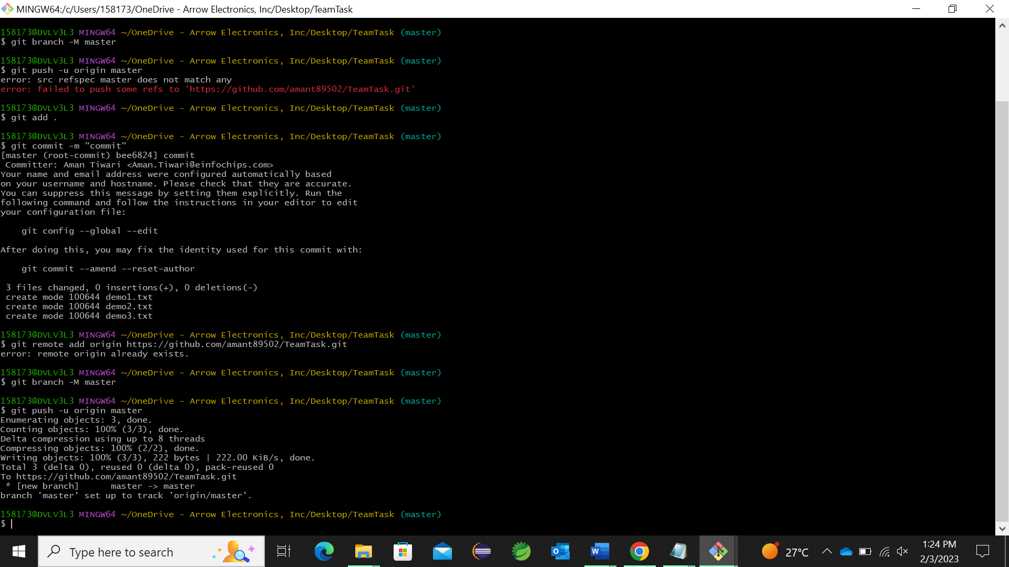

5. In other PC, we have created a clone from the one who created the github repository.

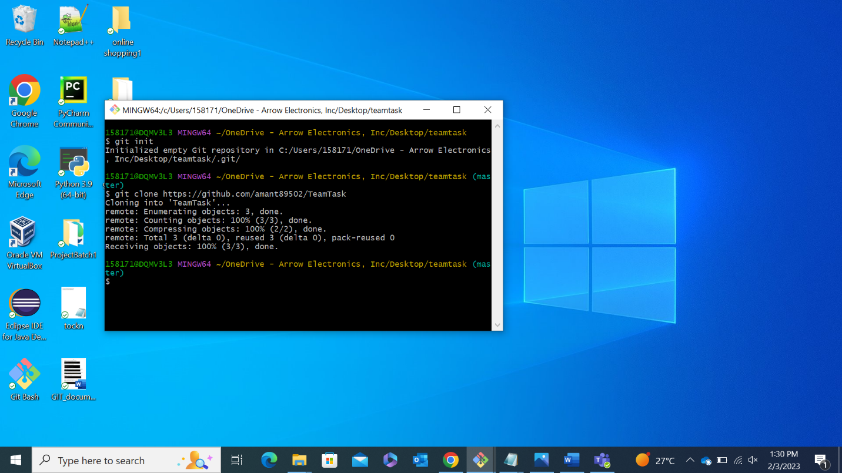

6. For creating fork, we have visited that link in Browser

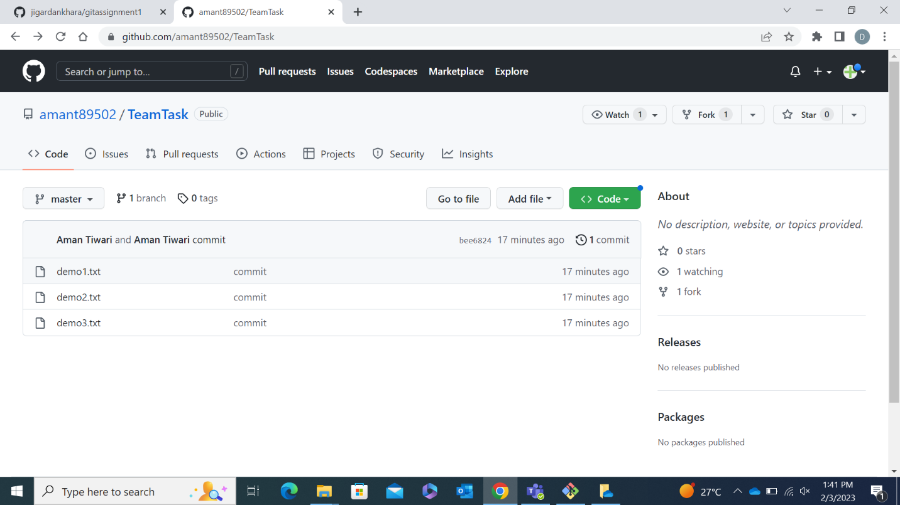

7. Here we have created a fork.

8. Now we have final fork link and we can copy it from here.

9. Here we have added origin from fork link. We have created branch named as develop.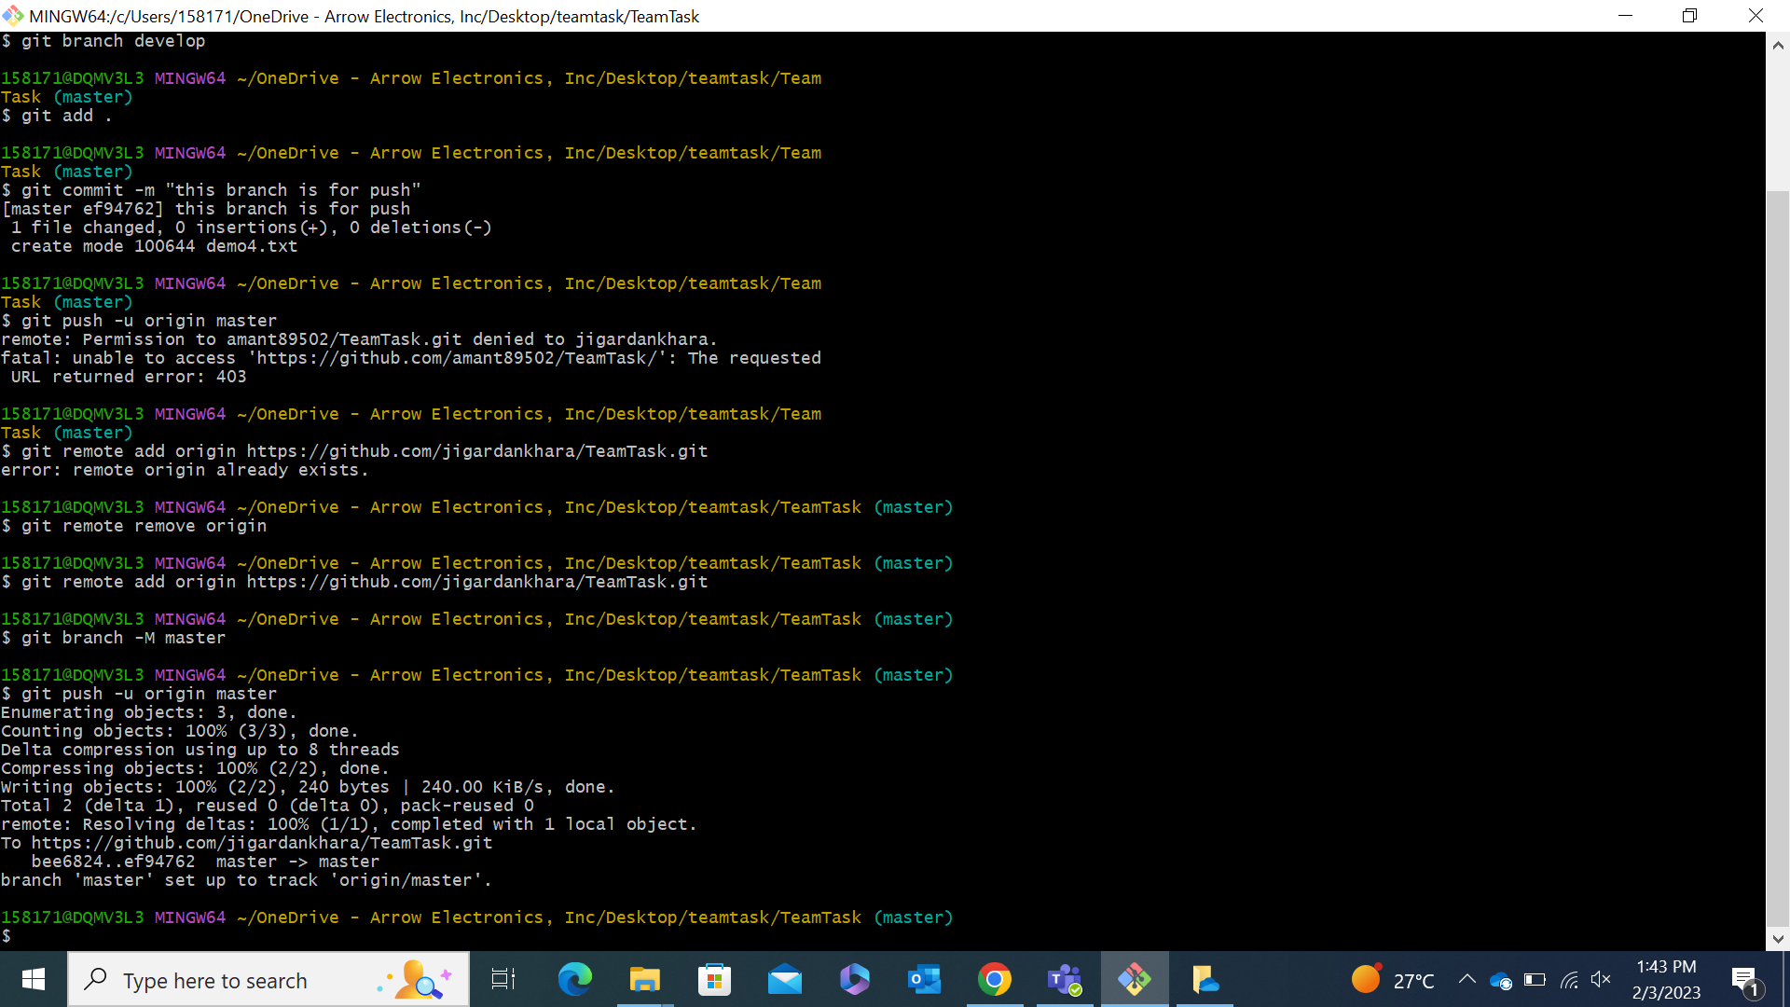

10. We have added demo4.txt file into the develop branch.

11. We have added file into stage area and then we pushed develop branch into github to create a pull request.

12. Now we are able to see pull request into a fork link.

13. After clicking the “Compare and pull request” button we are able to see this page. Here we can add comment in pull request

14. Now pull request is visible to the owner of github repository.

15. Here we can see the pull request named as “branch commit”.

16. Now owner can see the changes committed in the repository. If he wants changes then he can click on merge pull request.

17. After clicking on “merge pull request” we can see “confirm merge” button here.

18 Now we have clicked the confirm merge button to be done by owner.

19. Now we can see the new file is added to owner’s github repository.

